Name: PRATIK SUNIL ABHANG
Registration ID: 260640160209

Q1. Variable and String Manipulation

Question
Write a shell script that:
• Accepts your first name and last name as input.
• Stores them in variables.
• Displays:
o Full Name
o Length of the full name
o First character of the first name
o Last character of the last name

Program
#!/bin/bash
echo "Enter First Name:"
read fname
echo "Enter Last Name:"
read lname
fullname="$fname $lname"
echo "Full Name: $fullname"
echo "Length of Full Name: ${#fullname}"
echo "First Character: ${fname:0:1}"
echo "Last Character: ${lname: -1}"

Commands
nano q1.sh
cat q1.sh
bash q1.sh

Input and Output
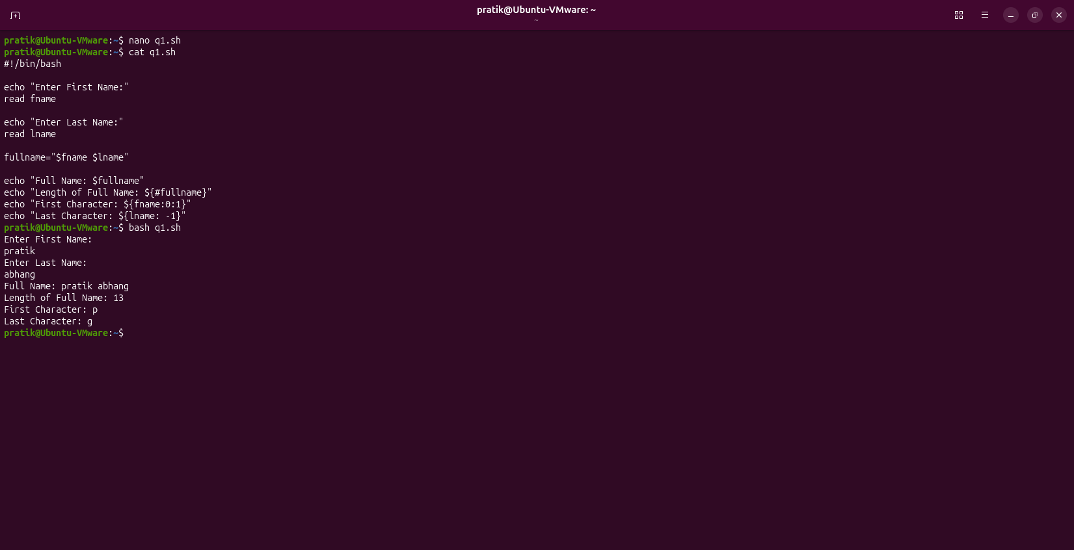

Q2. For Loop with Numbers

Question
Write a shell script that:
• Uses a for loop to print numbers from 1 to 20.
• Print "Even" beside even numbers and "Odd" beside odd numbers.

Program
#!/bin/bash
for ((i=1; i<=20; i++))
do
if [ $((i % 2)) -eq 0 ]
then
echo "$i - Even"
else
echo "$i - Odd"
fi
done

Commands
nano q2.sh
cat q2.sh
bash q2.sh

Input and Output
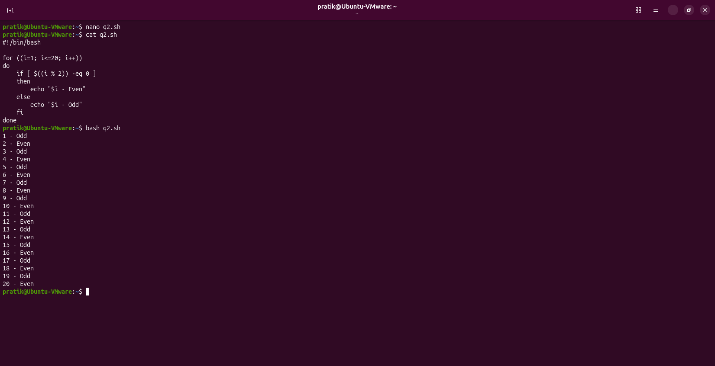

Q3. Directory Operations

Question
Write a shell script that:
• Accepts a directory name from the user.
• Checks whether it exists.
• If it exists, display total files and total directories.
• Otherwise display an appropriate message.

Program
#!/bin/bash
echo "Enter Directory Name:"
read dir
if [ -d "$dir" ]
then
echo "Directory Exists"
echo "Total Files:"
find "$dir" -maxdepth 1 -type f | wc -l
echo "Total Directories:"
find "$dir" -maxdepth 1 -type d | wc -l
else
echo "Directory Not Found"
fi

Commands
nano q3.sh
cat q3.sh
bash q3.sh

Input and Output
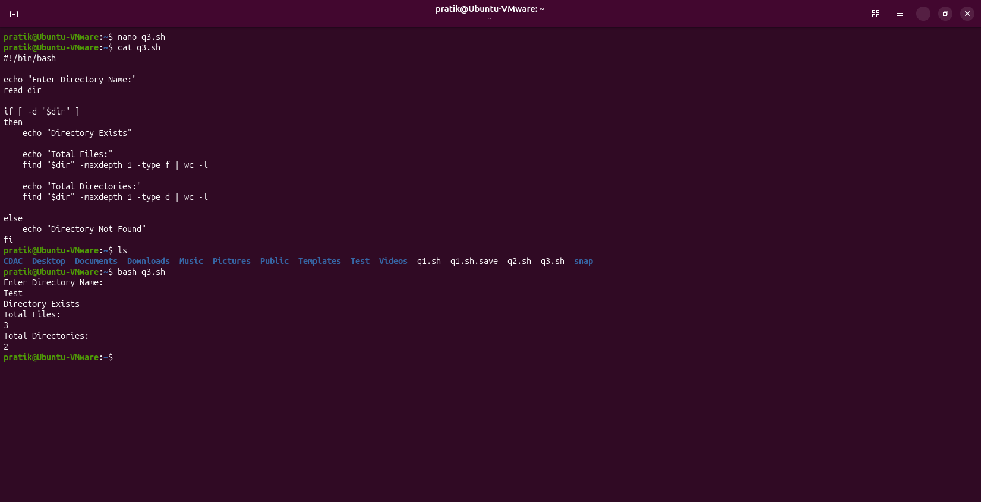

Q4. File Information

Question
Write a shell script that accepts a filename, checks whether it exists and displays file size, number of lines, number of words and readability/writability.

Program
#!/bin/bash
echo "Enter File Name:"
read file
if [ -e "$file" ]
then
echo "File Size:"
wc -c < "$file"
echo "Number of Lines:"
wc -l < "$file"
echo "Number of Words:"
wc -w < "$file"
if [ -r "$file" ]
then
echo "Readable"
fi
if [ -w "$file" ]
then
echo "Writable"
fi
else
echo "File Not Found"
fi

Commands
nano q4.sh
cat q4.sh
bash q4.sh

Input and Output
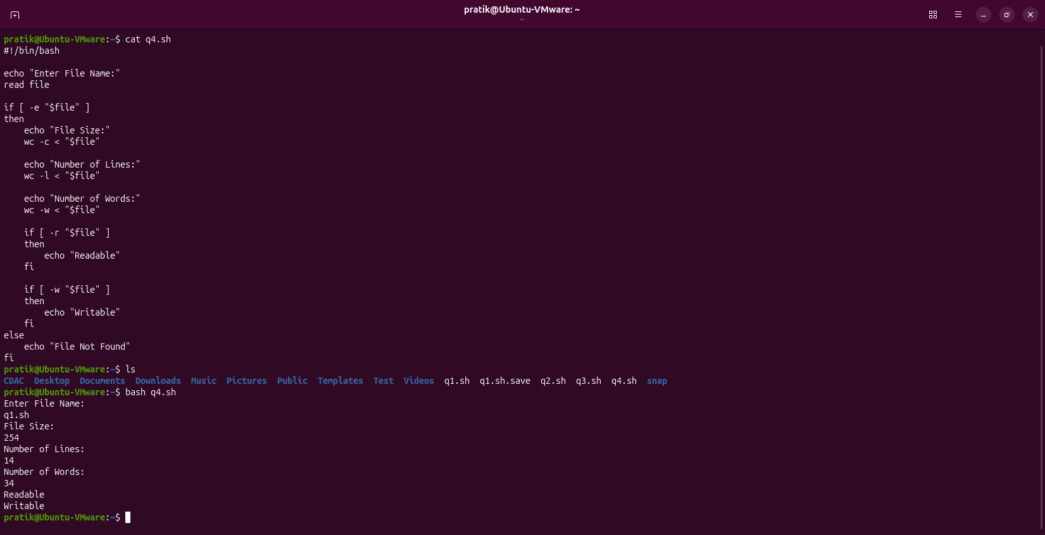

Q5. String Search

Question
Write a shell script that accepts a sentence and a word to search and displays Found or Not Found.

Program
#!/bin/bash
echo "Enter Sentence:"
read sentence
echo "Enter Word:"
read word
if echo "$sentence" | grep -q "$word"
then
echo "Found"
else
echo "Not Found"
fi

Commands
nano q5.sh
cat q5.sh
bash q5.sh

Input and Output
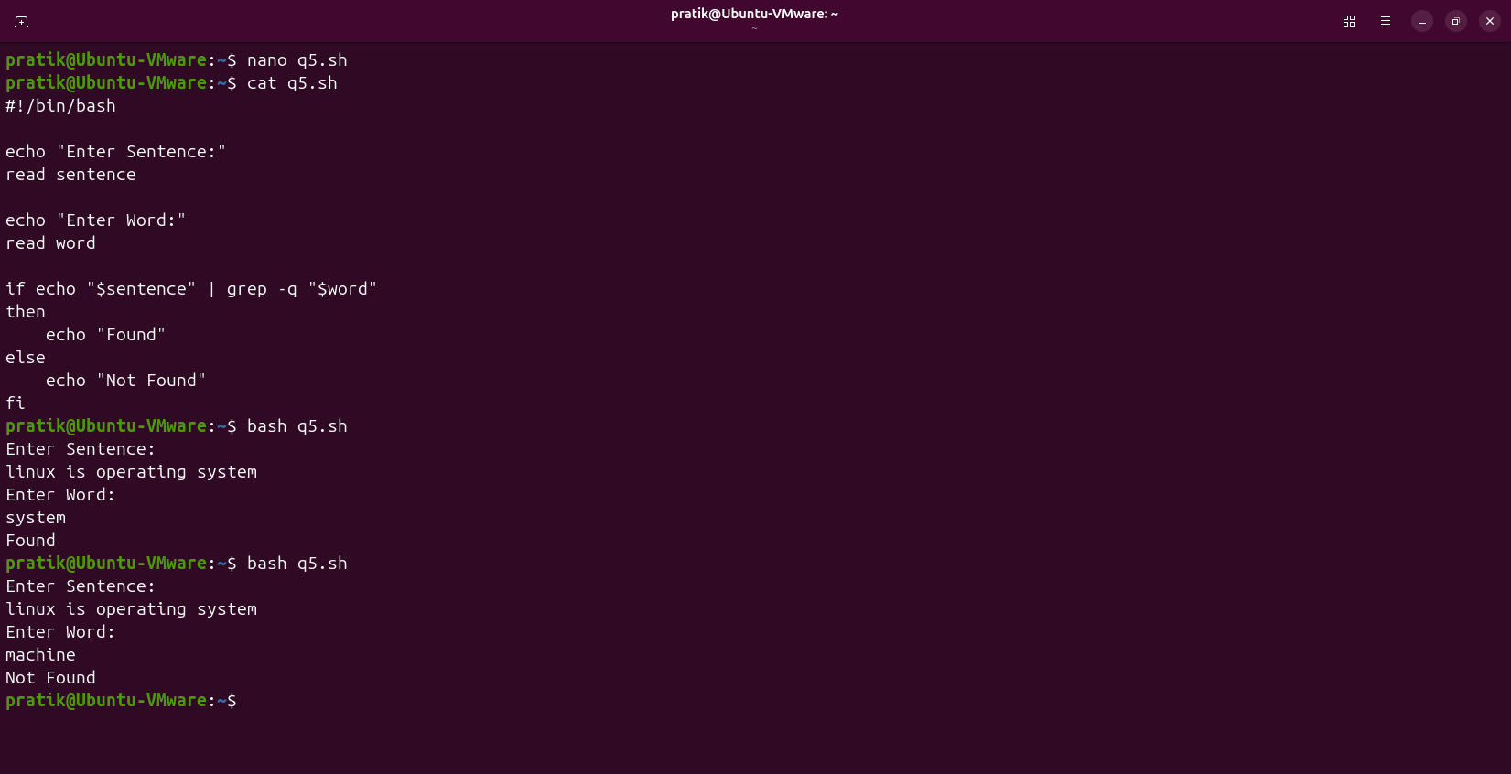

Q6. While Loop

Question
Write a shell script using a while loop to display numbers from 50 down to 1 and stop at 25.

Program
#!/bin/bash
i=50
while [ $i -ge 1 ]
do
echo $i
if [ $i -eq 25 ]
then
break
fi
i=$((i-1))
done

Commands
nano q6.sh
cat q6.sh
bash q6.sh

Input and Output
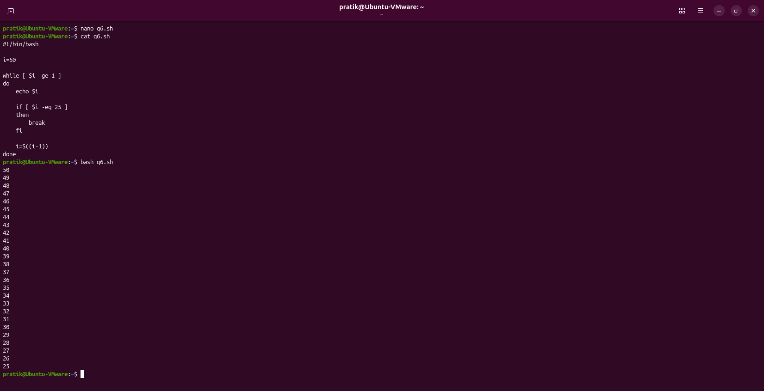

Q7. Until Loop

Question
Write a shell script using an until loop that prints numbers from 1 to 15 and their squares.

Program
#!/bin/bash
i=1
until [ $i -gt 15 ]
do
echo "$i -> $((i*i))"
i=$((i+1))
done

Commands
nano q7.sh
cat q7.sh
bash q7.sh

Input and Output
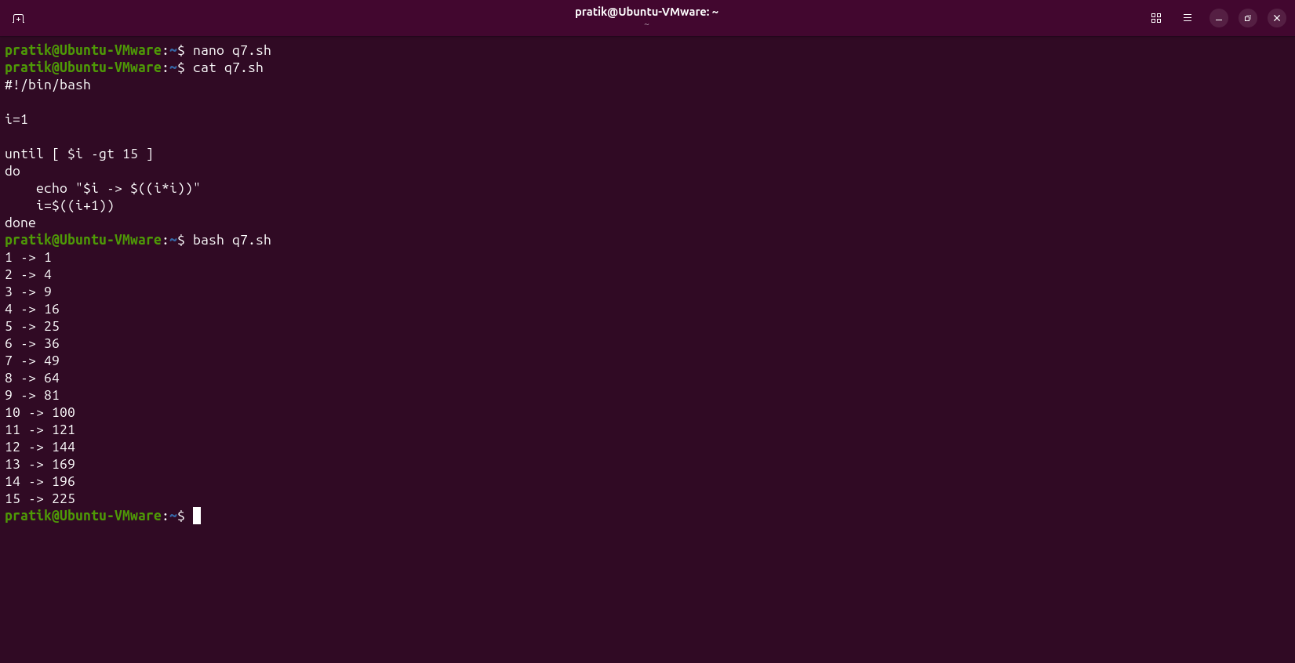

Q8. For Loop with Files

Question
Write a shell script to display all .txt files and their sizes.

Program
#!/bin/bash
for file in *.txt
do
if [ -f "$file" ]
then
echo "File Name: $file"
wc -c < "$file"
fi
done

Commands
nano q8.sh
cat q8.sh
bash q8.sh

Input and Output
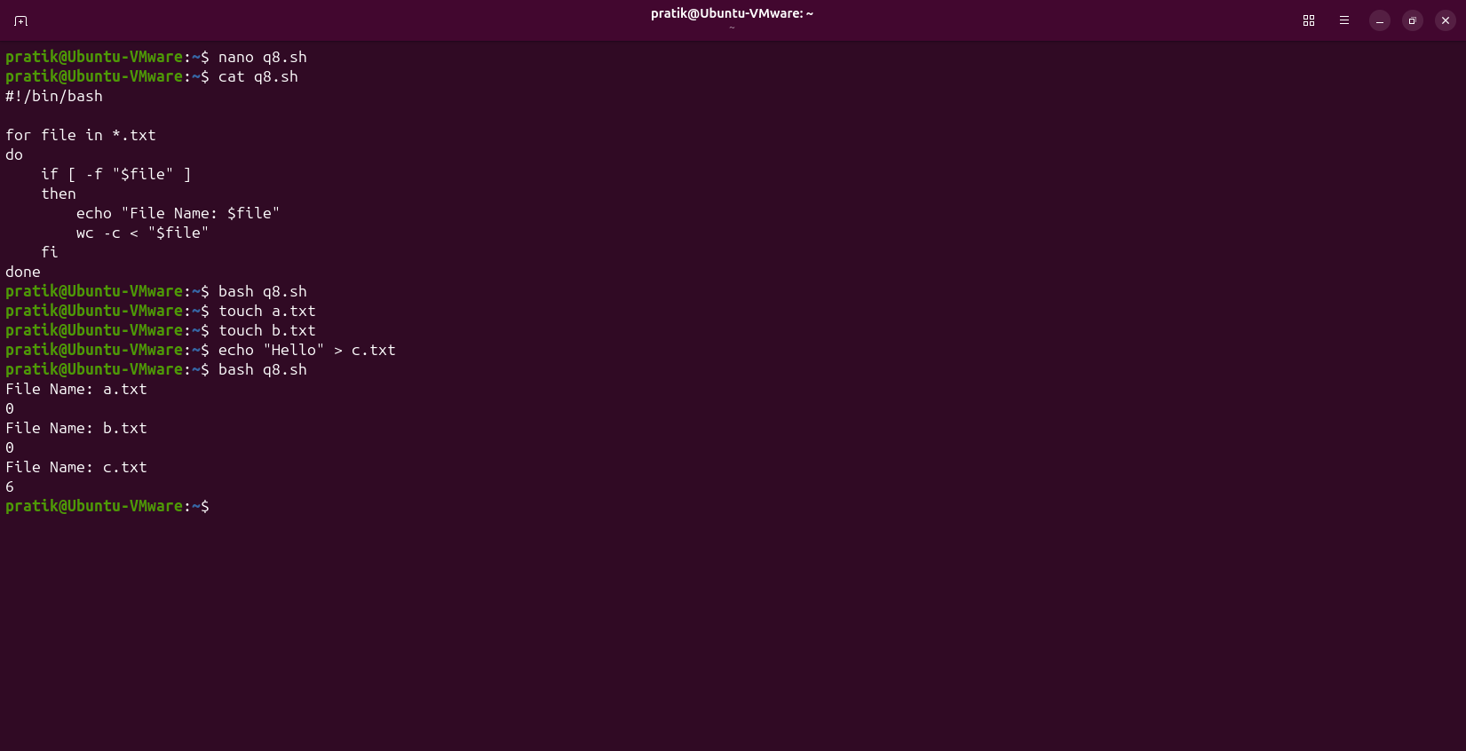

Q9. Variable, String and Loop

Question
Write a shell script to print each character of a word and total characters.

Program
#!/bin/bash
echo "Enter Word:"
read word
len=${#word}
for ((i=0; i<len; i++))
do
echo "${word:i:1}"
done
echo "Total Characters: $len"

Commands
nano q9.sh
cat q9.sh
bash q9.sh

Input and Output
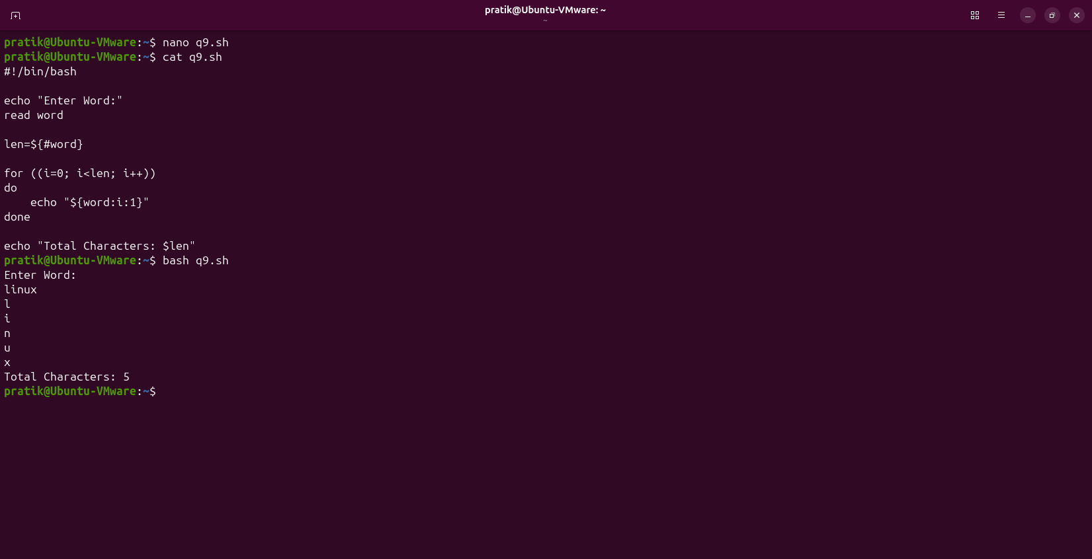

Q10. Until Loop with Directory Creation

Question
Write a shell script that repeatedly asks for a directory name until a new directory is entered, then creates it.

Program
#!/bin/bash
while true
do
echo "Enter Directory Name:"
read dir
if [ -d "$dir" ]
then
echo "Directory Already Exists"
else
mkdir "$dir"
echo "Directory Created Successfully"
break
fi
done

Commands
nano q10.sh
cat q10.sh
bash q10.sh

Input and Output
